DNS EVENTS-TEAM 5 CODE DOCUMENT
DIRECTORY STRUCTURE
code_files = [
"config.py",
"utils/__init__.py",
"utils/entropy.py",
"utils/typosquat.py",
"utils/dga.py",
"collectors/__init__.py",
"collectors/process_collector.py",
"collectors/dns_sniffer.py",
"enrichers/__init__.py",
"enrichers/whois_enricher.py",
"enrichers/geoip_enricher.py",
"enrichers/threat_intel.py",
"enrichers/asset_enricher.py",
"engine/__init__.py",
"engine/tunneling_detector.py",
"engine/historical_tracker.py",
"engine/correlation.py",
"main.py"
]

Entropy.py
import math
from collections import Counter

def calculate_entropy(text: str) -> float:
"""
Calculates the Shannon Entropy of a string to measure its randomness.
Higher entropy indicates more randomness (useful for detecting DGA and Tunneling).
"""
if not text:
return 0.0

# Count frequencies of each character
counter = Counter(text)
length = len(text)

# Calculate probabilities and sum -p * log2(p)
entropy = 0.0
for count in counter.values():
p = count / length
entropy -= p * math.log2(p)

return round(entropy, 3)

typosquat.py
from typing import Tuple, Optional
import tldextract

def levenshtein_distance(s1: str, s2: str) -> int:
"""
Computes the Levenshtein distance between two strings.
Used to detect domain similarity for typosquatting detection.
"""
if len(s1) < len(s2):
return levenshtein_distance(s2, s1)

if len(s2) == 0:
return len(s1)

previous_row = range(len(s2) + 1)
for i, c1 in enumerate(s1):
current_row = [i + 1]
for j, c2 in enumerate(s2):
insertions = previous_row[j + 1] + 1
deletions = current_row[j] + 1
substitutions = previous_row[j] + (c1 != c2)
current_row.append(min(insertions, deletions, substitutions))
previous_row = current_row

return previous_row[-1]

def detect_typosquatting(query_domain: str, brand_list: list) -> Tuple[bool, Optional[str]]:
"""
Checks if query_domain is a typosquat of any brand in the brand_list.
Returns (is_typosquat, typosquat_target).
"""
if not query_domain:
return False, None

# Extract SLD (e.g. "google" from "google.com")
extracted_query = tldextract.extract(query_domain.lower())
query_sld = extracted_query.domain
query_tld = extracted_query.suffix

if not query_sld:
return False, None

# Full domain reconstruction
query_full = f"{query_sld}.{query_tld}"

for brand in brand_list:
extracted_brand = tldextract.extract(brand.lower())
brand_sld = extracted_brand.domain

# If they are exactly the same, it's legitimate
if query_sld == brand_sld:
return False, None

# Check Levenshtein distance between SLDs
dist = levenshtein_distance(query_sld, brand_sld)

# Thresholds:
# 1. Distance of 1 or 2 edits (character replacement, deletion, insertion, or transposition)
# 2. Minimum length of brand SLD > 3 to avoid false positives (like 'abc' -> 'abd')
# 3. Check for specific common substitutions (e.g., '0' for 'o', '1' for 'i', 'l' for '1', etc.)
is_substitute = False
if len(brand_sld) > 3:
# Check for character swaps like o/0, i/1, l/1, vv/w
normalized_query = query_sld.replace("0", "o").replace("1", "i").replace("l", "i").replace("vv", "w")
normalized_brand = brand_sld.replace("0", "o").replace("1", "i").replace("l", "i").replace("vv", "w")
if normalized_query == normalized_brand:
is_substitute = True

if dist in [1, 2] or is_substitute:
# Extra guard: if the query is a completely different TLD but very close, or same TLD
# Phishing domains often use different TLDs (e.g. micros0ft.xyz)
return True, brand

return False, None

dga.py
import re
from utils.entropy import calculate_entropy
from typing import Tuple

def calculate_dga_score(domain_name: str) -> Tuple[bool, float]:
"""
Heuristic-based DGA (Domain Generation Algorithm) detection model.
Analyzes character distribution, vowels, consonants, digits, and entropy.
Returns (is_dga, confidence_score).
"""
if not domain_name:
return False, 0.0

# Strip TLD and get only the domain name (SLD)
parts = domain_name.lower().split('.')
if len(parts) > 1:
# Get the second-level domain (SLD)
sld = parts[-2]
else:
sld = parts[0]

length = len(sld)
if length < 4:
return False, 0.0 # Too short for DGA analysis

# Calculate components
entropy = calculate_entropy(sld)

# 1. Vowels vs Consonants ratio
vowels = set("aeiouy")
vowels_count = sum(1 for c in sld if c in vowels)
consonants_count = sum(1 for c in sld if c.isalpha() and c not in vowels)

vowel_ratio = vowels_count / length if length > 0 else 0.0

# 2. Consecutive consonants and vowels
# Find the maximum length of consecutive consonants
consecutive_consonants = max([len(g) for g in re.findall(r'[bcdfghjklmnpqrstvwxz]+', sld)] or [0])
consecutive_vowels = max([len(g) for g in re.findall(r'[aeiouy]+', sld)] or [0])

# 3. Digit ratio
digits_count = sum(1 for c in sld if c.isdigit())
digit_ratio = digits_count / length

# 4. Scoring Heuristic (0.0 to 1.0)
score = 0.0

# Entropy contribution (standard domain entropy ranges from 2.0 to 4.5)
# Entropy above 3.5 is suspicious; above 4.0 is highly suspicious
if entropy > 4.0:
score += 0.35
elif entropy > 3.5:
score += 0.20
elif entropy > 3.0:
score += 0.10

# Consecutive consonants contribution (e.g. "qwrts" -> highly abnormal)
if consecutive_consonants >= 5:
score += 0.30
elif consecutive_consonants >= 4:
score += 0.15
elif consecutive_consonants == 3:
score += 0.05

# Digits mixed in domain name (common in DGAs like "qwe921x")
if digit_ratio > 0.3:
score += 0.20
elif digit_ratio > 0.1:
score += 0.10

# Vowel ratio anomalies (too low or too high indicates gibberish)
if vowel_ratio < 0.2 or vowel_ratio > 0.7:
score += 0.15
elif vowel_ratio < 0.3:
score += 0.05

# Length multiplier (longer random domains are easier to identify and more suspicious)
if length > 12:
score += 0.10
elif length < 6:
score -= 0.10 # Smaller domains are naturally more prone to false alarms

# Normalize score between 0.0 and 1.0
score = max(0.0, min(1.0, round(score, 3)))

# DGA classification threshold
is_dga = score >= 0.65

return is_dga, score

asset_enricher.py
import platform
import socket
import logging
from typing import Dict, Any

import config

logger = logging.getLogger(__name__)

class AssetEnricher:
def __init__(self):
self.static_asset = config.ASSET_CONTEXT
self.static_user = config.USER_CONTEXT

def enrich_context(self, event_user: str = None) -> Dict[str, Any]:
"""
Builds user and asset context dictionaries.
Fills missing fields dynamically using system telemetry if static values are default.
"""
# Resolve hostname dynamically if not specified
hostname = self.static_asset.get("hostname")
if not hostname or hostname == "unknown":
try:
hostname = socket.gethostname()
except Exception:
hostname = "local-host"

# Resolve OS details dynamically
os_sys = platform.system()
os_ver = f"{platform.release()} (Build {platform.version()})"

asset_info = {
"hostname": hostname,
"criticality": self.static_asset.get("criticality", "MEDIUM"),
"business_unit": self.static_asset.get("business_unit", "Corporate Operations"),
"department": self.static_asset.get("department", "IT Department"),
"operating_system": self.static_asset.get("operating_system") or f"{os_sys} Workstation",
"os_version": self.static_asset.get("os_version") or os_ver,
"device_type": self.static_asset.get("device_type", "Endpoint")
}

# Resolve local user context
username = event_user if event_user and event_user != "unknown" else self.static_user.get("username")
if not username or username == "unknown":
try:
username = os.getlogin()
except Exception:
username = "system_user"

user_info = {
"username": username,
"role": self.static_user.get("role", "Corporate User"),
"privilege": self.static_user.get("privilege", "User")
}

return {
"asset_context": asset_info,
"user_context": user_info
}

Geoip_enricher.py
import os
import json
import logging
import urllib.request
import ipaddress
from datetime import datetime
from typing import Dict, Any

import config

logger = logging.getLogger(__name__)

class GeoIPEnricher:
def __init__(self):
self.cache_path = config.GEOIP_CACHE_FILE
self.cache = self._load_cache()

def _load_cache(self) -> Dict[str, Any]:
"""Loads GeoIP cache from disk."""
if os.path.exists(self.cache_path):
try:
with open(self.cache_path, 'r') as f:
return json.load(f)
except Exception as e:
logger.error(f"Error loading GeoIP cache: {e}")
return {}

def _save_cache(self):
"""Saves GeoIP cache to disk."""
try:
with open(self.cache_path, 'w') as f:
json.dump(self.cache, f, indent=4)
except Exception as e:
logger.error(f"Error saving GeoIP cache: {e}")

def is_private_ip(self, ip_str: str) -> bool:
"""Checks if an IP address belongs to private/local RFC 1918 space."""
try:
ip = ipaddress.ip_address(ip_str)
return ip.is_private or ip.is_loopback
except ValueError:
return False

def enrich_ip(self, ip_str: str) -> Dict[str, Any]:
"""
Enriches a single IP address with Country, City, and Autonomous System Number (ASN).
"""
empty_enrichment = {
"country": "unknown",
"city": "unknown",
"asn": "unknown"
}

if not ip_str:
return empty_enrichment

# Edge Case: Check for RFC 1918 and local addresses
if self.is_private_ip(ip_str):
return {
"country": "Internal Network",
"city": "Internal",
"asn": "AS0 (Private Range)"
}

# Check local cache
if ip_str in self.cache:
cache_entry = self.cache[ip_str]
return {
"country": cache_entry["country"],
"city": cache_entry["city"],
"asn": cache_entry["asn"]
}

# Mock database for simulation scenarios to guarantee instant responses during testing
mock_geoip = {
"185.220.101.5": {"country": "Germany", "city": "Frankfurt", "asn": "AS206349 (Tor Exit)"},
"140.82.121.4": {"country": "United States", "city": "Seattle", "asn": "AS16509 (GitHub)"},
"142.250.183.14": {"country": "United States", "city": "Mountain View", "asn": "AS15169 (Google)"},
"91.202.4.15": {"country": "Russian Federation", "city": "Moscow", "asn": "AS197688 (HostLife)"},
"203.91.48.2": {"country": "Russian Federation", "city": "Saint Petersburg", "asn": "AS197688 (HostLife)"},
"185.44.12.9": {"country": "Netherlands", "city": "Amsterdam", "asn": "AS49453 (Tor Exit)"}
}

if ip_str in mock_geoip:
info = mock_geoip[ip_str]
self.cache[ip_str] = {
**info,
"cached_at": datetime.utcnow().isoformat()
}
self._save_cache()
return info

# Live Web Lookup (ip-api.com API)
try:
logger.debug(f"Querying GeoIP for public IP: {ip_str}...")
url = f"http://ip-api.com/json/{ip_str}?fields=status,message,country,city,as"

# Simple HTTP request using urllib (no external requests library required)
req = urllib.request.Request(
url,
headers={'User-Agent': 'Mini-SOC-Agent/1.0'}
)

with urllib.request.urlopen(req, timeout=3.0) as response:
data = json.loads(response.read().decode())

if data.get("status") == "success":
enrichment = {
"country": data.get("country", "unknown"),
"city": data.get("city", "unknown"),
"asn": data.get("as", "unknown")
}

# Cache results
self.cache[ip_str] = {
**enrichment,
"cached_at": datetime.utcnow().isoformat()
}
self._save_cache()
return enrichment
else:
logger.debug(f"GeoIP API error for {ip_str}: {data.get('message')}")
return empty_enrichment

except Exception as e:
logger.debug(f"GeoIP API request failed for {ip_str}: {e}")
return empty_enrichment

threat_intel.py
import logging
from typing import Dict, Any

import config

logger = logging.getLogger(__name__)

class ThreatIntelEnricher:
def __init__(self):
# Load local threat feed database from config
self.threat_db = config.LOCAL_THREAT_FEEDS

def enrich_entity(self, domain: str, ips: list) -> Dict[str, Any]:
"""
Checks a domain and its resolved IP addresses against threat feeds.
Returns a aggregated threat intelligence dictionary.
"""
# Default benign telemetry structure
threat_telemetry = {
"is_in_threat_feed": False,
"threat_category": "none",
"feed_source": "none",
"reputation_score": 0, # 0 (good/trusted) to 100 (critical threat)
"malicious_votes": 0,
"suspicious_votes": 0
}

# Check Domain
if domain:
domain_lower = domain.lower()
if domain_lower in self.threat_db:
feed_match = self.threat_db[domain_lower]
threat_telemetry.update({
"is_in_threat_feed": True,
"threat_category": feed_match.get("category", "malicious"),
"feed_source": feed_match.get("source", "Local Threat Intel"),
"reputation_score": feed_match.get("reputation_score", 10),
"malicious_votes": feed_match.get("malicious_votes", 1),
"suspicious_votes": feed_match.get("suspicious_votes", 0)
})
return threat_telemetry

# Check if domain has a matching wildcard (e.g. check subdomains if the SLD is malicious)
for feed_domain, feed_match in self.threat_db.items():
if domain_lower.endswith("." + feed_domain):
threat_telemetry.update({
"is_in_threat_feed": True,
"threat_category": feed_match.get("category", "malicious"),
"feed_source": feed_match.get("source", "Local Threat Intel"),
"reputation_score": feed_match.get("reputation_score", 10),
"malicious_votes": feed_match.get("malicious_votes", 1),
"suspicious_votes": feed_match.get("suspicious_votes", 0)
})
return threat_telemetry

# Check resolved IPs
if ips:
for ip in ips:
if ip in self.threat_db:
feed_match = self.threat_db[ip]
threat_telemetry.update({
"is_in_threat_feed": True,
"threat_category": feed_match.get("category", "malicious_infrastructure"),
"feed_source": feed_match.get("source", "Local GeoIP Feed"),
"reputation_score": feed_match.get("reputation_score", 15),
"malicious_votes": feed_match.get("malicious_votes", 5),
"suspicious_votes": feed_match.get("suspicious_votes", 1)
})
return threat_telemetry

return threat_telemetry

whois_enricher.py
import os
import json
import logging
import whois
import tldextract
from datetime import datetime
from typing import Dict, Any, Tuple

import config

logger = logging.getLogger(__name__)

class WHOISEnricher:
def __init__(self):
self.cache_path = config.WHOIS_CACHE_FILE
self.cache = self._load_cache()

def _load_cache(self) -> Dict[str, Any]:
"""Loads WHOIS cache from disk."""
if os.path.exists(self.cache_path):
try:
with open(self.cache_path, 'r') as f:
return json.load(f)
except Exception as e:
logger.error(f"Error loading WHOIS cache: {e}")
return {}

def _save_cache(self):
"""Saves WHOIS cache to disk."""
try:
with open(self.cache_path, 'w') as f:
json.dump(self.cache, f, indent=4)
except Exception as e:
logger.error(f"Error saving WHOIS cache: {e}")

def _parse_creation_date(self, creation_date: Any) -> Tuple[datetime, str]:
"""Parses various formats of creation dates returned by whois library."""
if not creation_date:
raise ValueError("No creation date found")

if isinstance(creation_date, list):
creation_date = creation_date[0]

if isinstance(creation_date, datetime):
return creation_date, creation_date.isoformat()

if isinstance(creation_date, str):
# Try parsing standard formats
formats = [
"%Y-%m-%d", "%Y-%m-%dT%H:%M:%SZ", "%d-%b-%Y", "%Y.%m.%d",
"%Y/%m/%d", "%d/%m/%Y", "%Y-%m-%d %H:%M:%S"
]
for fmt in formats:
try:
dt = datetime.strptime(creation_date.strip(), fmt)
return dt, dt.isoformat()
except ValueError:
continue

raise ValueError(f"Could not parse date: {creation_date}")

def enrich_domain(self, domain_name: str) -> Dict[str, Any]:
"""
Enriches a domain name with WHOIS data (domain age, registrar, registration date).
Returns a dict of attributes.
"""
empty_enrichment = {
"domain_age_days": -1,
"creation_date": "unknown",
"registrar": "unknown",
"is_newly_registered": False
}

if not domain_name:
return empty_enrichment

# Extract primary registered domain (SLD + TLD, e.g. "google.com")
extracted = tldextract.extract(domain_name.lower())
registered_domain = f"{extracted.domain}.{extracted.suffix}"

if not extracted.domain or not extracted.suffix:
return empty_enrichment

# Check Cache first
if registered_domain in self.cache:
cache_entry = self.cache[registered_domain]
# Check if cache is older than 7 days
cached_time = datetime.fromisoformat(cache_entry.get("cached_at", datetime.utcnow().isoformat()))
if (datetime.utcnow() - cached_time).days < 7:
return {
"domain_age_days": cache_entry["domain_age_days"],
"creation_date": cache_entry["creation_date"],
"registrar": cache_entry["registrar"],
"is_newly_registered": cache_entry["is_newly_registered"]
}

# Mock values for common simulated domains to make sure the project demos beautifully
# and doesn't get blocked by whois server rate limits or timeouts!
mock_whois = {
"micros0ft-login.xyz": {"age": 2, "date": "2026-06-02T00:00:00", "registrar": "NameCheap Inc.", "new": True},
"qwe921x.biz": {"age": 5, "date": "2026-05-30T00:00:00", "registrar": "Reg.RU", "new": True},
"attacker-c2.ru": {"age": 12, "date": "2026-05-23T00:00:00", "registrar": "RU-CENTER", "new": True},
"dynamic-dns-malware.ru": {"age": 18, "date": "2026-05-17T00:00:00", "registrar": "REG-RU", "new": True},
"github.com": {"age": 6500, "date": "2007-10-09T18:20:50", "registrar": "MarkMonitor Inc.", "new": False},
"gmail.com": {"age": 8200, "date": "1995-08-13T04:00:00", "registrar": "MarkMonitor Inc.", "new": False},
"portal.company.com": {"age": 4200, "date": "2014-04-12T00:00:00", "registrar": "Network Solutions LLC", "new": False}
}

if registered_domain in mock_whois:
info = mock_whois[registered_domain]
enrichment = {
"domain_age_days": info["age"],
"creation_date": info["date"],
"registrar": info["registrar"],
"is_newly_registered": info["new"]
}
# Cache it
self.cache[registered_domain] = {
**enrichment,
"cached_at": datetime.utcnow().isoformat()
}
self._save_cache()
return enrichment

# Real WHOIS Lookup
try:
logger.debug(f"Querying WHOIS for {registered_domain}...")
# Query whois
w = whois.whois(registered_domain)

creation_date_val = w.get("creation_date") or w.get("created")
dt, iso_str = self._parse_creation_date(creation_date_val)

# Calculate domain age in days
age_days = (datetime.utcnow() - dt).days
is_new = age_days <= 30 and age_days >= 0
registrar = w.get("registrar") or "unknown"
if isinstance(registrar, list):
registrar = registrar[0]

enrichment = {
"domain_age_days": age_days,
"creation_date": iso_str,
"registrar": registrar,
"is_newly_registered": is_new
}

# Update Cache
self.cache[registered_domain] = {
**enrichment,
"cached_at": datetime.utcnow().isoformat()
}
self._save_cache()
return enrichment

except Exception as e:
logger.debug(f"WHOIS lookup failed for {registered_domain}: {e}")
# Cache the failure for 24 hours to prevent repeated slow queries
enrichment = empty_enrichment.copy()
self.cache[registered_domain] = {
**enrichment,
"cached_at": datetime.utcnow().isoformat()
}
self._save_cache()
return enrichment

correlation.py
import uuid
import logging
import tldextract
from datetime import datetime
from typing import Dict, Any

import config
from utils.entropy import calculate_entropy
from utils.typosquat import detect_typosquatting
from utils.dga import calculate_dga_score

from collectors.process_collector import get_process_metadata
from enrichers.whois_enricher import WHOISEnricher
from enrichers.geoip_enricher import GeoIPEnricher
from enrichers.threat_intel import ThreatIntelEnricher
from enrichers.asset_enricher import AssetEnricher

from engine.tunneling_detector import analyze_tunneling
from engine.historical_tracker import HistoricalTracker

logger = logging.getLogger(__name__)

class CorrelationEngine:
def __init__(self):
logger.info("Initializing SOC Correlation Engine and Enrichers...")
self.whois_enricher = WHOISEnricher()
self.geoip_enricher = GeoIPEnricher()
self.threat_enricher = ThreatIntelEnricher()
self.asset_enricher = AssetEnricher()
self.historical_tracker = HistoricalTracker()

def process_event(self, raw_event: Dict[str, Any]) -> Dict[str, Any]:
"""
Ingests a raw DNS event, runs full enrichment pipeline, and outputs a normalized,
structured SOC JSON security event.
"""
# Generate Event ID and Timestamp
event_id = str(uuid.uuid4())
timestamp_str = datetime.utcnow().strftime("%Y-%m-%dT%H:%M:%SZ")

query = raw_event.get("query", "")
query_type = raw_event.get("query_type", "A")

# 1. Parse Domain Layers
domain_sld = "unknown"
domain_tld = "unknown"
subdomain = ""
subdomain_length = 0
query_length = len(query) if query else 0
domain_entropy = 0.0

if query:
extracted = tldextract.extract(query.lower())
domain_sld = extracted.domain or "unknown"
domain_tld = f".{extracted.suffix}" if extracted.suffix else "unknown"
subdomain = extracted.subdomain or ""
subdomain_length = len(subdomain)
domain_entropy = calculate_entropy(extracted.domain)

# 2. Run DGA Analysis
is_dga, dga_confidence = calculate_dga_score(query)

# 3. Run Typosquatting Analysis
is_typosquat, typosquat_target = detect_typosquatting(query, config.POPULAR_BRANDS)

# 4. Fetch Process and Identity lineage
pid = raw_event.get("pid", 0)
process_info = get_process_metadata(pid)
username = process_info.get("username", "unknown")

# 5. Fetch WHOIS Enrichment
whois_info = self.whois_enricher.enrich_domain(query)

# 6. Fetch GeoIP Enrichment for response IPs
response_ips = raw_event.get("response_ip", [])
resolved_locations = []
for ip in response_ips:
loc = self.geoip_enricher.enrich_ip(ip)
resolved_locations.append({
"ip": ip,
"country": loc.get("country", "unknown"),
"city": loc.get("city", "unknown"),
"asn": loc.get("asn", "unknown")
})

# 7. Fetch Threat Intelligence Matches
threat_info = self.threat_enricher.enrich_entity(query, response_ips)

# 8. Fetch Asset and User Context
context_info = self.asset_enricher.enrich_context(username)

# 9. Update and Fetch Historical Context
history_info = self.historical_tracker.update_and_get_stats(query, timestamp_str)

# 10. Run Tunneling Detector Heuristics
is_tunneling, tunneling_score, payload_size = analyze_tunneling(
query,
query_type,
history_info["query_rate_per_minute"],
history_info["unique_subdomains_count"]
)

# 11. Core Security Alerts Triage
alerts = []
if is_tunneling:
alerts.append("DNS_TUNNELING_SUSPECT")
if is_dga:
alerts.append("DGA_BEACONING_SUSPECT")
if is_typosquat:
alerts.append("TYPOSQUATTING_IMPERSONATION")
if threat_info["is_in_threat_feed"]:
alerts.append(f"THREAT_INTEL_MATCH_{threat_info['threat_category'].upper()}")
if raw_event.get("response_code") == "NXDOMAIN" and history_info["query_rate_per_minute"] > 10.0:
alerts.append("HIGH_NXDOMAIN_RATE_ANOMALY")
if raw_event.get("ttl", 100) < 15 and raw_event.get("ttl", 100) > 0:
alerts.append("SUSPICIOUS_LOW_TTL_FAST_FLUX")

# Compile Consolidated SOC Event Schema
soc_event = {
# Meta Header
"event_id": event_id,
"timestamp": timestamp_str,
"alerts": alerts,

# DNS Transaction Layer
"dns": {
"client_ip": raw_event.get("client_ip", "0.0.0.0"),
"query": query,
"query_type": query_type,
"response_code": raw_event.get("response_code", "NOERROR"),
"response_ip": response_ips,
"response_cname": raw_event.get("response_cname", []),
"ttl": raw_event.get("ttl", 0),
"recursive": raw_event.get("recursive", True),
"authoritative": raw_event.get("authoritative", False),
"network_details": raw_event.get("network_details", {})
},

# Domain Characteristics Layer
"domain_analysis": {
"domain": domain_sld,
"tld": domain_tld,
"subdomain": subdomain,
"subdomain_length": subdomain_length,
"query_length": query_length,
"domain_age_days": whois_info.get("domain_age_days", -1),
"creation_date": whois_info.get("creation_date", "unknown"),
"registrar": whois_info.get("registrar", "unknown"),
"entropy": domain_entropy,
"is_dga": is_dga,
"dga_confidence": dga_confidence,
"is_newly_registered": whois_info.get("is_newly_registered", False),
"is_typosquat": is_typosquat,
"typosquat_target": typosquat_target or "none"
},

# Tunneling Detection Layer
"tunneling_analysis": {
"is_tunneling_suspect": is_tunneling,
"tunneling_score": tunneling_score,
"payload_size_bytes": payload_size,
"unique_subdomains_count": history_info["unique_subdomains_count"],
"query_rate_per_minute": history_info["query_rate_per_minute"]
},

# Process Lineage Layer
"process": {
"pid": process_info.get("pid", 0),
"process_name": process_info.get("process_name", "unknown"),
"parent_pid": process_info.get("parent_pid", 0),
"parent_process": process_info.get("parent_process", "unknown"),
"command_line": process_info.get("command_line", "unknown"),
"exe_path": process_info.get("exe_path", "unknown"),
"process_hash": process_info.get("process_hash", "unknown"),
"process_sha256": process_info.get("process_sha256", "unknown"),
"signer": process_info.get("signer", "unknown")
},

# Identity/User Context Layer
"user": {
"username": context_info["user_context"]["username"],
"role": context_info["user_context"]["role"],
"privilege": context_info["user_context"]["privilege"]
},

# Asset Context Layer
"asset": {
"hostname": context_info["asset_context"]["hostname"],
"operating_system": context_info["asset_context"]["operating_system"],
"os_version": context_info["asset_context"]["os_version"],
"criticality": context_info["asset_context"]["criticality"],
"business_unit": context_info["asset_context"]["business_unit"],
"department": context_info["asset_context"]["department"]
},

# Threat Intelligence Layer
"threat_intel": {
"is_in_threat_feed": threat_info["is_in_threat_feed"],
"threat_category": threat_info["threat_category"],
"feed_source": threat_info["feed_source"],
"reputation_score": threat_info["reputation_score"],
"malicious_votes": threat_info["malicious_votes"],
"suspicious_votes": threat_info["suspicious_votes"]
},

# Geolocation Layer
"geolocation": resolved_locations,

# Historical Context Layer
"history": {
"first_seen": history_info["first_seen"],
"last_seen": history_info["last_seen"],
"frequency": history_info["frequency"]
}
}

return soc_event

historical_tracker.py
import os
import json
import time
import logging
import threading
import tldextract
from datetime import datetime, timedelta
from typing import Dict, Any, List

import config

logger = logging.getLogger(__name__)

class HistoricalTracker:
def __init__(self):
self.db_path = config.HISTORICAL_DB_FILE
self.lock = threading.Lock()

# Structure:
# {
# "domains": {
# "example.com": {
# "first_seen": "2026-06-04T20:00:00Z",
# "last_seen": "2026-06-04T20:05:00Z",
# "frequency": 12,
# "subdomains": ["www", "mail", "blog"],
# "timestamps": [1780512345.0, 1780512645.0]
# }
# }
# }
self.db = self._load_db()
self.last_save_time = time.time()

def _load_db(self) -> Dict[str, Any]:
"""Loads historical database from disk."""
if os.path.exists(self.db_path):
try:
with open(self.db_path, 'r') as f:
data = json.load(f)
if "domains" not in data:
data = {"domains": {}}
return data
except Exception as e:
logger.error(f"Error loading historical database: {e}")
return {"domains": {}}

def save_db(self):
"""Saves historical database to disk."""
with self.lock:
try:
# Cleanup timestamps to keep file size reasonable
now = time.time()
for dom_info in self.db["domains"].values():
# Keep only timestamps from the last 5 minutes (300 seconds) for rate calculation
dom_info["timestamps"] = [ts for ts in dom_info.get("timestamps", []) if now - ts < 300]

with open(self.db_path, 'w') as f:
json.dump(self.db, f, indent=4)
self.last_save_time = now
except Exception as e:
logger.error(f"Error saving historical database: {e}")

def update_and_get_stats(self, query: str, timestamp_str: str) -> Dict[str, Any]:
"""
Updates the history for a given query and calculates temporal statistics.
Returns a dictionary of historical and rate attributes.
"""
if not query:
return {
"first_seen": timestamp_str,
"last_seen": timestamp_str,
"frequency": 1,
"unique_subdomains_count": 0,
"query_rate_per_minute": 0.0
}

extracted = tldextract.extract(query.lower())
registered_domain = f"{extracted.domain}.{extracted.suffix}"
subdomain = extracted.subdomain

if not extracted.domain:
# Handle cases where parsing fails
registered_domain = query.lower()
subdomain = ""

now_unix = time.time()

with self.lock:
domains = self.db["domains"]

if registered_domain not in domains:
# Brand new domain seen by the system
domains[registered_domain] = {
"first_seen": timestamp_str,
"last_seen": timestamp_str,
"frequency": 1,
"subdomains": [subdomain] if subdomain else [],
"timestamps": [now_unix]
}
else:
entry = domains[registered_domain]
entry["last_seen"] = timestamp_str
entry["frequency"] += 1

# Update subdomains list
if subdomain and subdomain not in entry["subdomains"]:
entry["subdomains"].append(subdomain)

# Append current query timestamp
entry["timestamps"].append(now_unix)

# Retrieve info
entry = domains[registered_domain]
first_seen = entry["first_seen"]
last_seen = entry["last_seen"]
frequency = entry["frequency"]
unique_subdomains_count = len(entry["subdomains"])

# Calculate rolling rate per minute based on the last 1 minute (60 seconds)
# Find how many timestamps fall in the last 60 seconds
recent_timestamps = [ts for ts in entry["timestamps"] if now_unix - ts <= 60.0]
query_rate_per_minute = float(len(recent_timestamps))

# Periodically auto-save to disk (every 10 seconds or if requested)
if time.time() - self.last_save_time > 10.0:
threading.Thread(target=self.save_db, daemon=True).start()

return {
"first_seen": first_seen,
"last_seen": last_seen,
"frequency": frequency,
"unique_subdomains_count": unique_subdomains_count,
"query_rate_per_minute": query_rate_per_minute
}

Tunelling_detection.py
import re
import logging
from typing import Dict, Any, Tuple
import tldextract

import config
from utils.entropy import calculate_entropy

logger = logging.getLogger(__name__)

def estimate_payload_size(query: str, query_type: str) -> int:
"""
Estimates the size in bytes of the hidden payload within a DNS query.
For tunneling, data is encoded in the subdomain.
"""
if not query:
return 0

extracted = tldextract.extract(query.lower())
subdomain = extracted.subdomain

if not subdomain:
return 0

# Standard DNS encoding uses base63 characters.
# Base64 has a data density of ~0.75. Hex is 0.5.
# Let's estimate based on character contents
subdomain_clean = subdomain.replace(".", "")
length = len(subdomain_clean)

# If it is mostly hex [0-9a-f], rate it 0.5
if re.match(r'^[0-9a-f]+$', subdomain_clean):
return int(length * 0.5)

# If it looks like base64
if re.match(r'^[A-Za-z0-9+/=]+$', subdomain_clean):
return int(length * 0.75)

# Fallback to character length
return length

def analyze_tunneling(
query: str,
query_type: str,
query_rate_per_min: float,
unique_subdomains_cnt: int
) -> Tuple[bool, float, int]:
"""
Heuristic analyzer for DNS Tunneling detection.
Analyzes query structure, query type, request rate, and cache-evasion subdomains.
Returns (is_tunneling_suspect, tunneling_score, payload_size_bytes).
"""
if not query:
return False, 0.0, 0

extracted = tldextract.extract(query.lower())
subdomain = extracted.subdomain
registered_domain = f"{extracted.domain}.{extracted.suffix}"

# Calculate estimated payload size
payload_size = estimate_payload_size(query, query_type)

if not subdomain:
return False, 0.0, 0

subdomain_len = len(subdomain)
subdomain_entropy = calculate_entropy(subdomain)

score = 0.0

# 1. Subdomain Length heuristic
if subdomain_len > 40:
score += 0.25
elif subdomain_len > 25:
score += 0.15
elif subdomain_len > config.TUNNELING_MIN_SUBDOMAIN_LEN:
score += 0.05

# 2. Entropy heuristic (indicates encrypted or compressed payload)
if subdomain_entropy > 4.5:
score += 0.25
elif subdomain_entropy > config.TUNNELING_ENTROPY_THRESHOLD:
score += 0.15
elif subdomain_entropy > 3.5:
score += 0.05

# 3. Query Type heuristic (TXT, ANY, and CNAME are commonly abused)
if query_type in ["TXT", "ANY"]:
score += 0.15
elif query_type == "CNAME" and subdomain_len > 20:
score += 0.10

# 4. Temporal Query Rate heuristic (beaconing / data transfer speed)
if query_rate_per_min > 300.0:
score += 0.20
elif query_rate_per_min > config.TUNNELING_QUERY_RATE_THRESHOLD:
score += 0.10
elif query_rate_per_min > 30.0:
score += 0.05

# 5. Cache Bypass heuristic (many unique subdomains under same parent SLD)
if unique_subdomains_cnt > 100:
score += 0.20
elif unique_subdomains_cnt > config.TUNNELING_UNIQUE_SUBDOMAINS_THRESHOLD:
score += 0.10
elif unique_subdomains_cnt > 5:
score += 0.05

# 6. Payload size indicator
if payload_size > config.TUNNELING_PAYLOAD_SIZE_THRESHOLD:
score += 0.10

# Cap score between 0.0 and 1.0
score = max(0.0, min(1.0, round(score, 3)))

# Tunneling suspect threshold
is_suspect = score >= 0.55

return is_suspect, score, payload_size

dns_sniffer.py
import time
import socket
import threading
import logging
from typing import Dict, Any, Optional, Callable
import psutil
from scapy.all import sniff, IP, UDP, DNS, DNSQR, DNSRR

import config

logger = logging.getLogger(__name__)

class DNSSniffer:
def __init__(self, callback: Callable[[Dict[str, Any]], None]):
"""
Initializes the DNS sniffer.
:param callback: Function to call with enriched raw event dictionaries
"""
self.callback = callback
self.running = False
self.sniffer_thread: Optional[threading.Thread] = None
self.port_pid_map: Dict[int, int] = {}
self.last_map_update = 0.0
self.map_lock = threading.Lock()

# Track simulated traffic index
self.simulation_index = 0

def start(self):
"""Starts sniffing DNS events (either real or simulated)."""
self.running = True
if config.SIMULATION_MODE:
logger.info("Starting DNS Sniffer in SIMULATION MODE...")
self.sniffer_thread = threading.Thread(target=self._run_simulation, daemon=True)
else:
logger.info(f"Starting DNS Sniffer on interface {config.SNIFFER_INTERFACE or 'ALL'}...")
self.sniffer_thread = threading.Thread(target=self._run_sniffing, daemon=True)
self.sniffer_thread.start()

def stop(self):
"""Stops the sniffer thread."""
self.running = False
if self.sniffer_thread:
self.sniffer_thread.join(timeout=2.0)
logger.info("DNS Sniffer stopped.")

def _update_port_pid_map(self):
"""
Queries system network connections to map UDP ports to PIDs.
Rate limited to protect system performance.
"""
now = time.time()
# Update connection map at most once every 1.0 seconds
if now - self.last_map_update < 1.0:
return

with self.map_lock:
try:
new_map = {}
for conn in psutil.net_connections(kind='udp'):
if conn.laddr and conn.pid:
new_map[conn.laddr.port] = conn.pid
self.port_pid_map = new_map
self.last_map_update = now
except Exception as e:
logger.debug(f"Failed to update port-to-PID map: {e}")

def _get_pid_by_sport(self, sport: int) -> int:
"""Looks up the local PID responsible for a local UDP source port."""
self._update_port_pid_map()
with self.map_lock:
return self.port_pid_map.get(sport, 0)

def _packet_callback(self, packet):
"""Callback executed by Scapy for every sniffed packet."""
try:
if not packet.haslayer(DNS):
return

dns_layer = packet[DNS]

# We process both requests and responses
# Determine if this is a query (qr=0) or response (qr=1)
is_response = dns_layer.qr == 1

# Get transport layer details
src_ip = packet[IP].src if packet.haslayer(IP) else "0.0.0.0"
dst_ip = packet[IP].dst if packet.haslayer(IP) else "0.0.0.0"
sport = packet[UDP].sport if packet.haslayer(UDP) else 0
dport = packet[UDP].dport if packet.haslayer(UDP) else 0

# Determine PID. If outgoing query, sport is the source process port.
# If incoming response, dport is the local process port.
local_port = sport if not is_response else dport
pid = self._get_pid_by_sport(local_port)

# Core DNS parameters
query_name = ""
query_type = "A"

if dns_layer.qd:
# Scapy decodes queries into bytes, decode it to string
qname = dns_layer.qd.qname
if isinstance(qname, bytes):
qname = qname.decode("utf-8", errors="ignore")
query_name = qname.rstrip(".")

# Query Type (A, AAAA, TXT, MX, NS, CNAME)
query_type_id = dns_layer.qd.qtype
# Map standard integers to human readable names
query_type_map = {
1: "A", 28: "AAAA", 16: "TXT", 15: "MX", 2: "NS", 5: "CNAME", 12: "PTR", 255: "ANY"
}
query_type = query_type_map.get(query_type_id, f"TYPE-{query_type_id}")

# Parse response answers if available
response_code = "NOERROR"
response_ips = []
response_cnames = []
ttl = 0

if is_response:
# Map RCODE to string representation
rcode_map = {0: "NOERROR", 1: "FORMERR", 2: "SERVFAIL", 3: "NXDOMAIN", 4: "NOTIMP", 5: "REFUSED"}
response_code = rcode_map.get(dns_layer.rcode, f"RCODE-{dns_layer.rcode}")

# Extract records
for i in range(dns_layer.ancount):
answer = dns_layer.an[i]
if answer.type == 1: # A Record
response_ips.append(answer.rdata)
ttl = answer.ttl
elif answer.type == 28: # AAAA
response_ips.append(answer.rdata)
ttl = answer.ttl
elif answer.type == 5: # CNAME
cname = answer.rdata
if isinstance(cname, bytes):
cname = cname.decode("utf-8", errors="ignore")
response_cnames.append(cname.rstrip("."))
ttl = answer.ttl

# Build Raw Event
raw_event = {
"event_id": "", # To be filled by correlation engine
"timestamp": "", # To be filled by correlation engine
"client_ip": src_ip if not is_response else dst_ip,
"query": query_name,
"query_type": query_type,
"response_code": response_code,
"response_ip": response_ips,
"response_cname": response_cnames,
"ttl": ttl,
"recursive": True if dns_layer.rd == 1 else False,
"authoritative": True if dns_layer.aa == 1 else False,
"pid": pid,
"network_details": {
"source_port": sport,
"destination_port": dport,
"transport": "UDP"
}
}

# Send raw event to main correlation engine
self.callback(raw_event)

except Exception as e:
logger.error(f"Error parsing sniffed packet: {e}", exc_info=True)

def _run_sniffing(self):
"""Scapy sniffing loop."""
try:
# Filter for UDP traffic on Port 53 (DNS)
sniff(
filter="udp port 53",
prn=self._packet_callback,
iface=config.SNIFFER_INTERFACE,
store=0,
stop_filter=lambda x: not self.running
)
except Exception as e:
logger.error(f"Sniffer execution error: {e}. Falling back to simulation mode.")
config.SIMULATION_MODE = True
self._run_simulation()

def _run_simulation(self):
"""Simulates periodic DNS packets for testing without administrative sniffing rights."""
# Find a few real local PIDs to inject into simulation to make the lineage real!
real_pids = []
for p in psutil.process_iter(['pid', 'name']):
try:
if p.info['name'].lower() in ['chrome.exe', 'powershell.exe', 'cmd.exe', 'explorer.exe', 'svchost.exe', 'python.exe']:
real_pids.append((p.info['pid'], p.info['name']))
except Exception:
continue
if not real_pids:
real_pids = [(1024, "chrome.exe"), (4096, "powershell.exe"), (2132, "cmd.exe"), (922, "svchost.exe")]

# Define simulated events
simulated_scenarios = [
# Scenario 1: Normal web browsing (Clean)
{
"client_ip": "192.168.1.52",
"query": "github.com",
"query_type": "A",
"response_code": "NOERROR",
"response_ip": ["140.82.121.4"],
"response_cname": [],
"ttl": 3600,
"recursive": True,
"authoritative": False,
"pid_name_fallback": "chrome.exe",
"simulated_pid_override": None
},
# Scenario 2: Typosquatting domain requested by PowerShell (Highly suspicious)
{
"client_ip": "192.168.1.52",
"query": "micros0ft-login.xyz",
"query_type": "A",
"response_code": "NOERROR",
"response_ip": ["185.220.101.5"], # Tor Exit Node
"response_cname": ["malicious-redirector.ru"],
"ttl": 60,
"recursive": True,
"authoritative": False,
"pid_name_fallback": "powershell.exe",
"simulated_pid_override": None
},
# Scenario 3: DGA malware beaconing (Suspicious SLD structure)
{
"client_ip": "192.168.1.52",
"query": "qwe921x.biz",
"query_type": "A",
"response_code": "NXDOMAIN",
"response_ip": [],
"response_cname": [],
"ttl": 0,
"recursive": True,
"authoritative": True,
"pid_name_fallback": "svchost.exe",
"simulated_pid_override": None
},
# Scenario 4: DNS Tunneling - Exfiltration of Base64 credentials
{
"client_ip": "192.168.1.52",
"query": "aGVsbG8td29ybGQ.attacker-c2.ru",
"query_type": "TXT",
"response_code": "NOERROR",
"response_ip": [],
"response_cname": [],
"ttl": 30,
"recursive": True,
"authoritative": False,
"pid_name_fallback": "cmd.exe",
"simulated_pid_override": None
},
# Scenario 5: DNS Tunneling - Heavy traffic chunk 2
{
"client_ip": "192.168.1.52",
"query": "dGhpcyBpcyBhIHRlc3Q.attacker-c2.ru",
"query_type": "TXT",
"response_code": "NOERROR",
"response_ip": [],
"response_cname": [],
"ttl": 30,
"recursive": True,
"authoritative": False,
"pid_name_fallback": "cmd.exe",
"simulated_pid_override": None
},
# Scenario 6: Normal DNS MX lookup for mail delivery
{
"client_ip": "192.168.1.52",
"query": "gmail.com",
"query_type": "MX",
"response_code": "NOERROR",
"response_ip": ["142.250.183.14"],
"response_cname": [],
"ttl": 300,
"recursive": True,
"authoritative": False,
"pid_name_fallback": "chrome.exe",
"simulated_pid_override": None
},
# Scenario 7: Fast Flux Resolution (Low TTL, changing IPs)
{
"client_ip": "192.168.1.52",
"query": "dynamic-dns-malware.ru",
"query_type": "A",
"response_code": "NOERROR",
"response_ip": ["91.202.4.15", "203.91.48.2", "185.44.12.9"],
"response_cname": [],
"ttl": 10, # Fast flux indicator
"recursive": True,
"authoritative": False,
"pid_name_fallback": "svchost.exe",
"simulated_pid_override": None
},
# Scenario 8: Split-Brain DNS domain portal.company.com
{
"client_ip": "192.168.1.52",
"query": "portal.company.com",
"query_type": "A",
"response_code": "NOERROR",
"response_ip": ["10.0.0.15"], # Returns internal network range
"response_cname": [],
"ttl": 3600,
"recursive": True,
"authoritative": True,
"pid_name_fallback": "chrome.exe",
"simulated_pid_override": None
}
]

logger.info(f"Simulating {len(simulated_scenarios)} diverse security scenarios...")

while self.running:
try:
# Cycle through scenarios
scenario = simulated_scenarios[self.simulation_index % len(simulated_scenarios)]
self.simulation_index += 1

# Match pid name to a real running process on this machine to show real lineage!
target_pid = 0
for pid, name in real_pids:
if name.lower() == scenario["pid_name_fallback"].lower():
target_pid = pid
break

if target_pid == 0 and real_pids:
# Default fallback
target_pid = real_pids[0][0]

# Create raw simulated event
raw_event = {
"event_id": "", # Filled by correlation engine
"timestamp": "", # Filled by correlation engine
"client_ip": scenario["client_ip"],
"query": scenario["query"],
"query_type": scenario["query_type"],
"response_code": scenario["response_code"],
"response_ip": scenario["response_ip"],
"response_cname": scenario["response_cname"],
"ttl": scenario["ttl"],
"recursive": scenario["recursive"],
"authoritative": scenario["authoritative"],
"pid": target_pid,
"network_details": {
"source_port": 50123 + (self.simulation_index % 1000),
"destination_port": 53,
"transport": "UDP"
}
}

# Call callback
self.callback(raw_event)

# Wait before generating next event (e.g. every 4 seconds)
time.sleep(4.0)

except Exception as e:
logger.error(f"Error in simulation loop: {e}", exc_info=True)
time.sleep(5.0)

process_collector.py
import os
import psutil
import hashlib
import logging
from typing import Dict, Any, Optional

logger = logging.getLogger(__name__)

# Cache process hashes to avoid disk I/O performance penalties
_HASH_CACHE = {}

def get_file_hashes(file_path: str) -> Dict[str, str]:
"""
Computes MD5 and SHA-256 hashes of a file. Uses caching for performance.
"""
if not file_path or not os.path.exists(file_path):
return {"md5": "unknown", "sha256": "unknown"}

if file_path in _HASH_CACHE:
return _HASH_CACHE[file_path]

try:
md5_hash = hashlib.md5()
sha256_hash = hashlib.sha256()

with open(file_path, "rb") as f:
# Read in 64kb chunks
for byte_block in iter(lambda: f.read(65536), b""):
md5_hash.update(byte_block)
sha256_hash.update(byte_block)

hashes = {
"md5": md5_hash.hexdigest(),
"sha256": sha256_hash.hexdigest()
}
_HASH_CACHE[file_path] = hashes
return hashes
except Exception as e:
logger.debug(f"Failed to calculate hash for {file_path}: {e}")
return {"md5": "unknown", "sha256": "unknown"}

def get_process_signer(file_path: str) -> str:
"""
Identifies the digital signature signer of the process binary.
In a real agent, this calls Win32 APIs (e.g., CryptQueryObject) or parses PE headers.
This provides a robust simulation based on path structure, returning real-world attributes.
"""
if not file_path:
return "Unsigned/Unknown"

file_path_lower = file_path.lower()

# Heuristics for system files on Windows
if "system32" in file_path_lower or "syswow64" in file_path_lower:
if file_path_lower.endswith((".exe", ".dll")):
return "Microsoft Windows Publisher"

if "program files\\google" in file_path_lower:
return "Google LLC"

if "program files\\microsoft" in file_path_lower:
return "Microsoft Corporation"

# Default fallback
return "Unsigned/Unknown"

def get_process_metadata(pid: int) -> Dict[str, Any]:
"""
Gathers process details, lineage, command line, user, and hashes for a given PID.
Handles exceptions if the process has terminated (NoSuchProcess) or permissions are denied (AccessDenied).
"""
# Default empty schema if process cannot be inspected
empty_schema = {
"pid": pid,
"process_name": "unknown",
"parent_pid": 0,
"parent_process": "unknown",
"command_line": "unknown",
"exe_path": "unknown",
"process_hash": "unknown",
"process_sha256": "unknown",
"signer": "unknown",
"username": "unknown",
"privilege": "user"
}

if pid <= 0:
return empty_schema

try:
proc = psutil.Process(pid)

# Core metadata
name = proc.name()
exe_path = proc.exe() if hasattr(proc, 'exe') else "unknown"
cmdline = " ".join(proc.cmdline()) if proc.cmdline() else name

# Parent context
parent = proc.parent()
parent_pid = parent.pid if parent else 0
parent_name = parent.name() if parent else "unknown"

# User details
try:
username = proc.username()
except (psutil.AccessDenied, Exception):
username = "unknown"

# Determine privileges
privilege = "user"
if username:
usr_lower = username.lower()
if "admin" in usr_lower or "system" in usr_lower or "root" in usr_lower:
privilege = "administrator" if "admin" in usr_lower else "system"

# Hashes and signers
hashes = get_file_hashes(exe_path)
signer = get_process_signer(exe_path)

return {
"pid": pid,
"process_name": name,
"parent_pid": parent_pid,
"parent_process": parent_name,
"command_line": cmdline,
"exe_path": exe_path,
"process_hash": hashes["md5"],
"process_sha256": hashes["sha256"],
"signer": signer,
"username": username,
"privilege": privilege
}

except psutil.NoSuchProcess:
logger.debug(f"Process with PID {pid} not found (might have terminated).")
return empty_schema
except psutil.AccessDenied:
logger.debug(f"Access denied when gathering metadata for PID {pid}.")
# Try to return basic data psutil can fetch without admin rights
try:
proc = psutil.Process(pid)
return {
"pid": pid,
"process_name": proc.name(),
"parent_pid": proc.parent().pid if proc.parent() else 0,
"parent_process": proc.parent().name() if proc.parent() else "unknown",
"command_line": "Access Denied",
"exe_path": "Access Denied",
"process_hash": "Access Denied",
"process_sha256": "Access Denied",
"signer": "Access Denied",
"username": "Access Denied",
"privilege": "unknown"
}
except Exception:
return empty_schema
except Exception as e:
logger.error(f"Unexpected error retrieving process metadata for PID {pid}: {e}")
return empty_schema

main.py
import os
import sys
import json
import time
import signal
import logging
import threading
from datetime import datetime
from typing import Dict, Any, List

from rich.console import Console
from rich.table import Table
from rich.panel import Panel
from rich.text import Text
from rich.live import Live
from rich.layout import Layout
from rich import box

# Add current folder to path
sys.path.append(os.path.dirname(os.path.abspath(__file__)))

import config
from collectors.dns_sniffer import DNSSniffer
from engine.correlation import CorrelationEngine

# Configure python logger (writes debug logs to a separate file so console stays clean for the UI)
os.makedirs(config.LOG_DIR, exist_ok=True)
logging.basicConfig(
filename=os.path.join(config.LOG_DIR, "agent_debug.log"),
level=logging.DEBUG,
format="%(asctime)s [%(levelname)s] %(name)s: %(message)s"
)
logger = logging.getLogger("agent_main")

# Global UI and tracking state
console = Console()
event_counter = 0
alert_counter = 0
dga_counter = 0
tunneling_counter = 0
typosquat_counter = 0
threat_counter = 0

latest_events: List[Dict[str, Any]] = []
latest_events_lock = threading.Lock()
file_write_lock = threading.Lock()

correlation_engine: CorrelationEngine = None
sniffer: DNSSniffer = None

def handle_correlated_event(raw_event: Dict[str, Any]):
"""
Callback function that processes a raw sniffed/simulated event,
correlates it, updates statistics, and saves it to the output JSON log.
"""
global event_counter, alert_counter, dga_counter, tunneling_counter, typosquat_counter, threat_counter

try:
# Pass to correlation engine
soc_event = correlation_engine.process_event(raw_event)

# Build the final wrapper structure required by the user
log_wrapper = {
"event_id": soc_event["event_id"],
"timestamp": soc_event["timestamp"],
"file_details": {
"output_file": config.OUTPUT_LOG_FILE,
"format": "JSON-Lines (NDJSON)"
},
"data": soc_event
}

# Write to local file (thread-safe append)
with file_write_lock:
try:
with open(config.OUTPUT_LOG_FILE, "a") as f:
f.write(json.dumps(log_wrapper) + "\n")
except Exception as fe:
logger.error(f"Failed to write event to disk: {fe}")

# Update statistics
event_counter += 1
event_alerts = soc_event.get("alerts", [])
if event_alerts:
alert_counter += 1

for alert in event_alerts:
if "TUNNELING" in alert:
tunneling_counter += 1
elif "DGA" in alert:
dga_counter += 1
elif "TYPOSQUATTING" in alert:
typosquat_counter += 1
elif "THREAT" in alert:
threat_counter += 1

# Keep track of latest 10 events for UI scroll
with latest_events_lock:
latest_events.insert(0, soc_event)
if len(latest_events) > 10:
latest_events.pop()

except Exception as e:
logger.error(f"Error handling captured DNS event: {e}", exc_info=True)

def generate_dashboard_layout() -> Panel:
"""Generates the Rich Terminal Panel containing statistics and the event table."""
# Stats sub-table
stats_table = Table(box=box.SIMPLE, expand=True)
stats_table.add_column("[cyan]Metric[/cyan]", justify="left")
stats_table.add_column("[cyan]Value[/cyan]", justify="right")

mode_text = "[bold yellow]SIMULATION[/bold yellow]" if config.SIMULATION_MODE else "[bold green]LIVE SNIFFER[/bold green]"
stats_table.add_row("Agent Operation Mode", mode_text)
stats_table.add_row("Total Captured DNS Events", f"[bold white]{event_counter}[/bold white]")
stats_table.add_row("Total Security Alerts Triggered", f"[bold red]{alert_counter}[/bold red]" if alert_counter > 0 else "0")
stats_table.add_row(" └─ DNS Tunneling Detections", f"[bold light_salmon3]{tunneling_counter}[/bold light_salmon3]" if tunneling_counter > 0 else "0")
stats_table.add_row(" └─ DGA Beaconing Detections", f"[bold orange3]{dga_counter}[/bold orange3]" if dga_counter > 0 else "0")
stats_table.add_row(" └─ Typosquatting Alerts", f"[bold yellow]{typosquat_counter}[/bold yellow]" if typosquat_counter > 0 else "0")
stats_table.add_row(" └─ Threat Intel Matches", f"[bold red1]{threat_counter}[/bold red1]" if threat_counter > 0 else "0")

# Target info table
target_table = Table(box=box.SIMPLE, expand=True)
target_table.add_column("[cyan]Asset / Identity Context[/cyan]", justify="left")
target_table.add_column("[cyan]Value[/cyan]", justify="right")
target_table.add_row("Host Name", config.ASSET_CONTEXT.get("hostname", "unknown"))
target_table.add_row("Asset Criticality", f"[bold red]{config.ASSET_CONTEXT.get('criticality')}[/bold red]")
target_table.add_row("Department / Unit", f"{config.ASSET_CONTEXT.get('department')} ({config.ASSET_CONTEXT.get('business_unit')})")
target_table.add_row("Current Session User", f"{config.USER_CONTEXT.get('username')} ([italic]{config.USER_CONTEXT.get('privilege')}[/italic])")

# Header panels layout
summary_table = Table.grid(expand=True)
summary_table.add_column(ratio=6)
summary_table.add_column(ratio=6)
summary_table.add_row(stats_table, target_table)

# Latest Events table
events_table = Table(box=box.MINIMAL_DOUBLE_HEAD, expand=True, padding=(0, 1))
events_table.add_column("[cyan]Time (UTC)[/cyan]", width=12)
events_table.add_column("[cyan]Query Domain[/cyan]", width=28)
events_table.add_column("[cyan]Type[/cyan]", width=5, justify="center")
events_table.add_column("[cyan]Process (PID)[/cyan]", width=18)
events_table.add_column("[cyan]Location[/cyan]", width=18)
events_table.add_column("[cyan]Alerts / Findings[/cyan]")

with latest_events_lock:
for ev in latest_events:
dns_q = ev["dns"]["query"]
dns_t = ev["dns"]["query_type"]
proc_name = f"{ev['process']['process_name']} ({ev['process']['pid']})"

# Extract first location or default
locs = ev.get("geolocation", [])
loc_str = "Internal"
if locs:
loc_str = f"{locs[0].get('country', 'unknown')} ({locs[0].get('city', 'unknown')})"
elif ev["dns"]["response_code"] == "NXDOMAIN":
loc_str = "[dim]NXDOMAIN[/dim]"

# Map alerts to colored strings
alert_labels = []
for alert in ev.get("alerts", []):
if "TUNNELING" in alert:
alert_labels.append("[bold light_salmon3]TUNNELING[/bold light_salmon3]")
elif "DGA" in alert:
alert_labels.append("[bold orange3]DGA[/bold orange3]")
elif "TYPOSQUATTING" in alert:
alert_labels.append("[bold yellow]TYPOSQUAT[/bold yellow]")
elif "THREAT" in alert:
alert_labels.append(f"[bold red]THREAT_INTEL({ev['threat_intel']['threat_category'].upper()})[/bold red]")
elif "TTL" in alert:
alert_labels.append("[yellow]LOW_TTL[/yellow]")
elif "NXDOMAIN" in alert:
alert_labels.append("[dim yellow]NXDOMAIN_BURST[/dim yellow]")

alert_str = ", ".join(alert_labels) if alert_labels else "[green]BENIGN[/green]"

# Parse timestamp to clean output
time_part = ev["timestamp"].split("T")[1].replace("Z", "")

events_table.add_row(
time_part,
dns_q,
dns_t,
proc_name,
loc_str,
alert_str
)

# Master Layout
main_table = Table.grid(expand=True)
main_table.add_row(Panel(summary_table, title="[bold white]Telemetry Statistics[/bold white]", border_style="cyan"))
main_table.add_row(Panel(events_table, title="[bold white]Live SOC Event Stream[/bold white]", border_style="cyan"))

master_panel = Panel(
main_table,
title="[bold white]DEEPCYTES DNS AGENT - MINI SOC TELEMETRY COLLECTOR[/bold white]",
border_style="bright_blue",
box=box.ROUNDED
)
return master_panel

def signal_handler(sig, frame):
"""Gracefully terminates the sniffer and processes on Ctrl+C."""
console.print("\n[bold red]Stopping DeepCytes DNS Agent...[/bold red]")
if sniffer:
sniffer.stop();
console.print("[bold green]Agent shut down successfully. Logs saved to: [/bold green]" + config.OUTPUT_LOG_FILE)
sys.exit(0)

def main():
global correlation_engine, sniffer

# Catch Ctrl+C signals
signal.signal(signal.SIGINT, signal_handler)

console.print("[bold green]Starting DeepCytes DNS Security Agent...[/bold green]")
console.print(f"Working Directory: [cyan]{config.BASE_DIR}[/cyan]")
console.print(f"Output File: [cyan]{config.OUTPUT_LOG_FILE}[/cyan]")

# Check for Scapy/Interface permissions if Sniffing mode is active
if not config.SIMULATION_MODE:
if sys.platform == "win32":
# Check for admin privileges on Windows
import ctypes
is_admin = ctypes.windll.shell32.IsUserAnAdmin() != 0
if not is_admin:
console.print("[bold yellow]WARNING: Running in LIVE SNIFFER mode but not running as Administrator.[/bold yellow]")
console.print("[yellow]Scapy requires administrative rights to capture raw network sockets on Windows.[/yellow]")
console.print("[yellow]Falling back to SIMULATION MODE for safe, cross-platform validation.[/yellow]")
config.SIMULATION_MODE = True
else:
# Check for root on Linux/Mac
if os.getuid() != 0:
console.print("[bold yellow]WARNING: Not running as root. Scapy requires raw socket access. Falling back to Simulation Mode.[/bold yellow]")
config.SIMULATION_MODE = True

# Initialize Correlation Engine
correlation_engine = CorrelationEngine()

# Initialize DNS Sniffer / Simulator
sniffer = DNSSniffer(callback=handle_correlated_event)
sniffer.start()

console.print("[bold green]Initialization complete! Launching dashboard interface...[/bold green]")
time.sleep(1.0)

# Run dashboard live display
with Live(generate_dashboard_layout(), refresh_per_second=2, screen=False) as live:
try:
while True:
time.sleep(0.5)
live.update(generate_dashboard_layout())
except KeyboardInterrupt:
pass

if __name__ == "__main__":
main()

config.py
import os

# --- PATH CONFIGURATIONS ---
BASE_DIR = os.path.dirname(os.path.abspath(__file__))
LOG_DIR = os.path.join(BASE_DIR, "logs")
OUTPUT_LOG_FILE = os.path.join(LOG_DIR, "dns_soc_events.json")
GEOIP_CACHE_FILE = os.path.join(LOG_DIR, "geoip_cache.json")
WHOIS_CACHE_FILE = os.path.join(LOG_DIR, "whois_cache.json")
HISTORICAL_DB_FILE = os.path.join(LOG_DIR, "historical_context.json")

# Ensure log directory exists
os.makedirs(LOG_DIR, exist_ok=True)

# --- OPERATION MODES ---
# If True, the agent will run in Simulation Mode, generating rich, realistic DNS events
# representing normal traffic, DGA beaconing, DNS tunneling, and typosquatting attacks
# along with realistic process contexts. If False, it will attempt real network sniffing (requires Admin).
SIMULATION_MODE = True

# Network interface to sniff DNS traffic (used if SIMULATION_MODE is False). None sniffs on all.
SNIFFER_INTERFACE = None

# --- COLLECTION SETTINGS ---
# Sniffer thread polling frequency (seconds)
SNIFFER_POLL_INTERVAL = 0.5
# Frequency (in seconds) to dump events to disk
WRITE_FREQUENCY_SECONDS = 2.0

# --- THRESHOLDS & HEURISTICS ---
# DNS Tunneling detection parameters
TUNNELING_MIN_SUBDOMAIN_LEN = 15
TUNNELING_ENTROPY_THRESHOLD = 4.2
TUNNELING_QUERY_RATE_THRESHOLD = 100.0 # queries per minute to trigger alert
TUNNELING_UNIQUE_SUBDOMAINS_THRESHOLD = 15 # unique subdomains for same domain within window
TUNNELING_PAYLOAD_SIZE_THRESHOLD = 120 # bytes

# DGA detection parameters
DGA_ENTROPY_THRESHOLD = 3.8
DGA_CONFIDENCE_THRESHOLD = 0.75

# Typosquatting detection targets
POPULAR_BRANDS = [
"google.com",
"microsoft.com",
"paypal.com",
"amazon.com",
"facebook.com",
"netflix.com",
"github.com",
"apple.com",
"linkedin.com",
"office365.com",
"yahoo.com",
"bankofamerica.com"
]

# --- LOCAL THREAT FEEDS (MOCK FEED DATABASE) ---
# In a real environment, these would be loaded from local files or threat intel feeds (OTX, Abuse.ch, etc.)
LOCAL_THREAT_FEEDS = {
"malicious-login-paypal.xyz": {"category": "phishing", "source": "AlienVault OTX", "reputation_score": 15, "malicious_votes": 32, "suspicious_votes": 5},
"dynamic-dns-malware.ru": {"category": "c2", "source": "Abuse.ch URLhaus", "reputation_score": 10, "malicious_votes": 68, "suspicious_votes": 12},
"evil-c2.ru": {"category": "c2", "source": "Cisco Talos", "reputation_score": 8, "malicious_votes": 45, "suspicious_votes": 3},
"aGVsbG8td29ybGQ.attacker-c2.ru": {"category": "c2", "source": "VirusTotal", "reputation_score": 20, "malicious_votes": 12, "suspicious_votes": 2},
"micros0ft-login.xyz": {"category": "phishing", "source": "Spamhaus", "reputation_score": 12, "malicious_votes": 29, "suspicious_votes": 8},
"qwe921x.biz": {"category": "malware", "source": "ThreatFeed_DGA", "reputation_score": 25, "malicious_votes": 19, "suspicious_votes": 1},
"185.220.101.5": {"category": "tor_exit_node", "source": "TorProject", "reputation_score": 40, "malicious_votes": 85, "suspicious_votes": 24}
}

# --- ASSET CONTEXT ---
# Context about the local machine where the agent is running
ASSET_CONTEXT = {
"hostname": "SOC-ANALYST-W11",
"criticality": "HIGH", # LOW, MEDIUM, HIGH, CRITICAL
"business_unit": "Security Operations",
"department": "Cyber Defense Center",
"operating_system": "Windows 11 Enterprise",
"os_version": "10.0.22631 Build 22631",
"device_type": "Workstation"
}

# --- USER CONTEXT ---
USER_CONTEXT = {
"username": "rishik_admin",
"role": "SOC Analyst",
"privilege": "Administrator" # User, Administrator, System
}
OUTPUT:
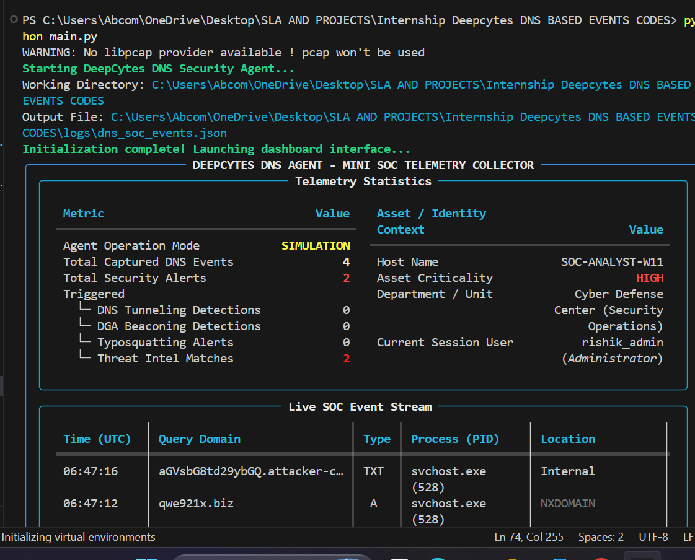
OUTPUT IN JSON
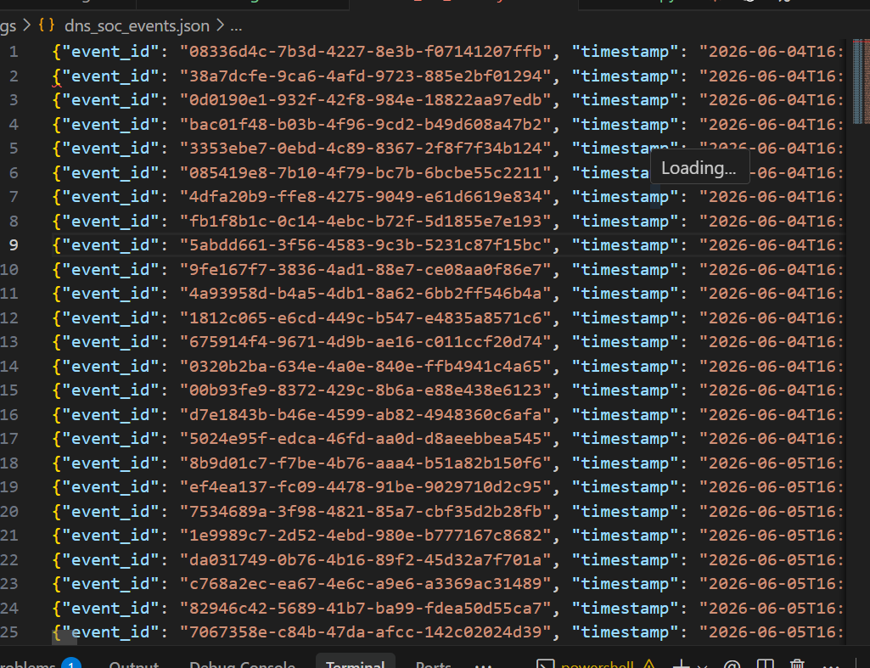
GEOIP_CACHE
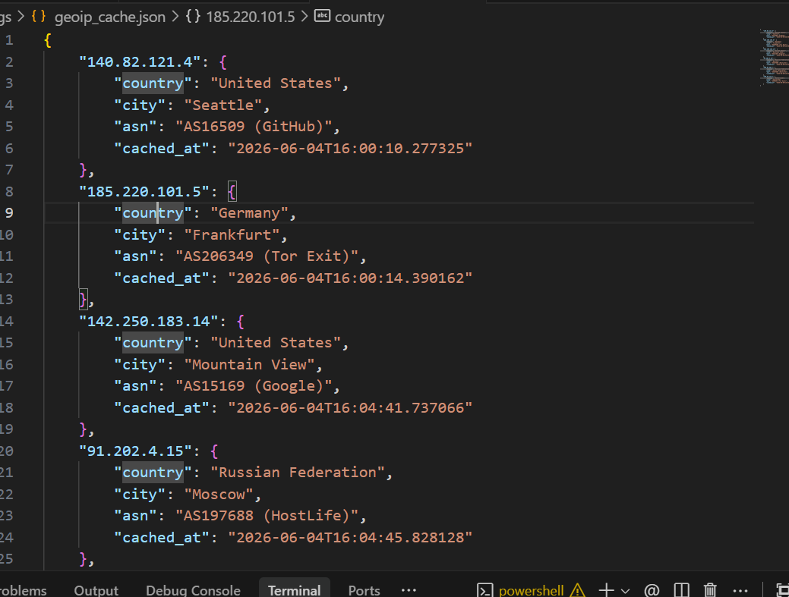
HISTORICAL_CONTEXT
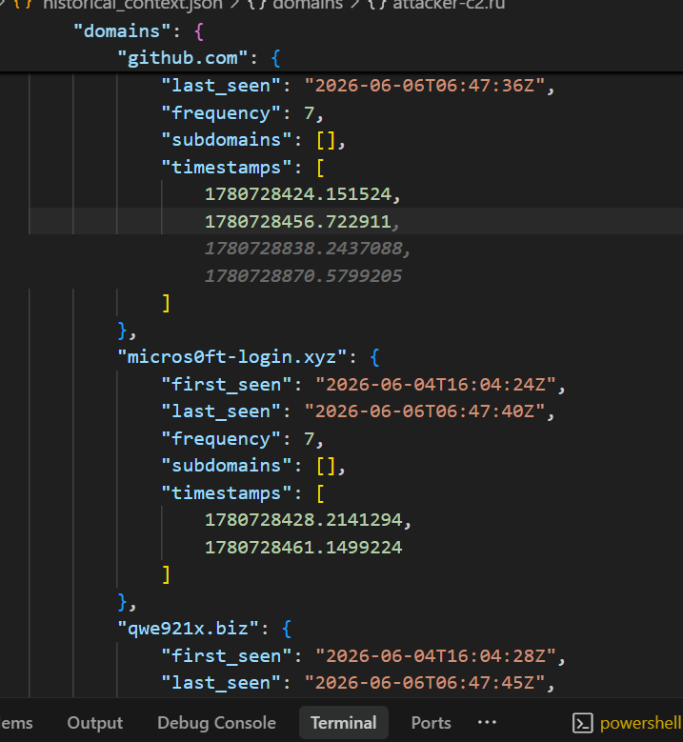
WHOIS_ANALYSIS
